22U ENCLOSURE 19" CABINET 600X800 FLOOR STANDING DATA RACK - ECO NETCAB
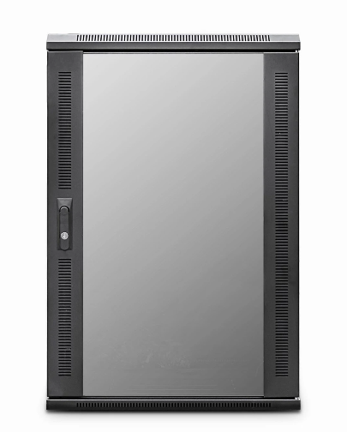

DESCRIPTION
Redefining quality ergonomics for your telco, networking & PBX needs
Cost-effective and quality enclosures for your structured cabling, networking and
broadcast projects.
The LMS Data EcoNetCab is the defacto standard in offering great choice
and quality enclosure solutions, be it structured cabling for your copper or
fibre networking, LAN or WAN networking deployment or broadcast
A/V for companies of all sizes.
Designed for the installer and IT manager, all enclosure come with useful
features to make your installation that much easier, together with bundled free
accessories mean you’ve got everything you need to get your new installation up
an running, with minimal fuss or downtime.

SPECIFICATIONS
22U high 600W 800D
ETSI 19” front/rear profiles (adjustable)
Removable side/rear panels, RAL 9005
Front tempered glass door (lockable)

TECHNICAL INFO
SKU/MPN: CAB-FE-22U-68
EAN: 8400800015945
Weight: 50Kg
Dimensions: 600 (width) x800(depth) x1160mm (height)

FILES
Datasheet - CAB-FE-22U-68

